Task on Docker
- Setup a virtual machine using Ubuntu image.
Created an instance with AMI as ubuntu
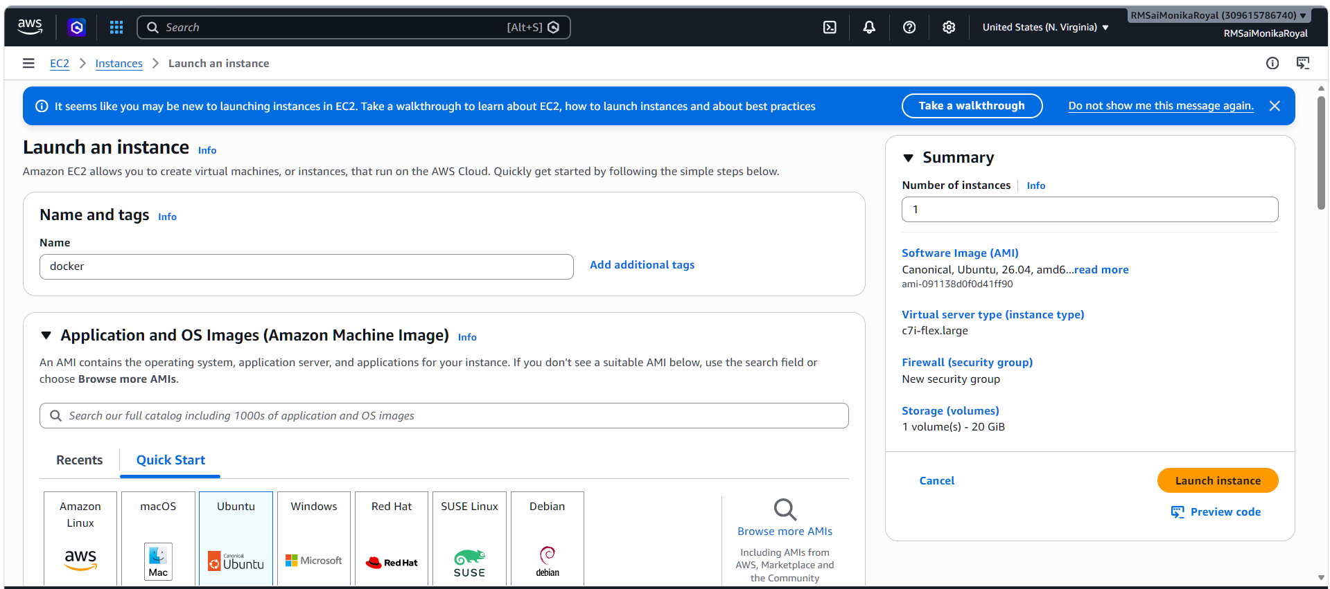
Connected the instance
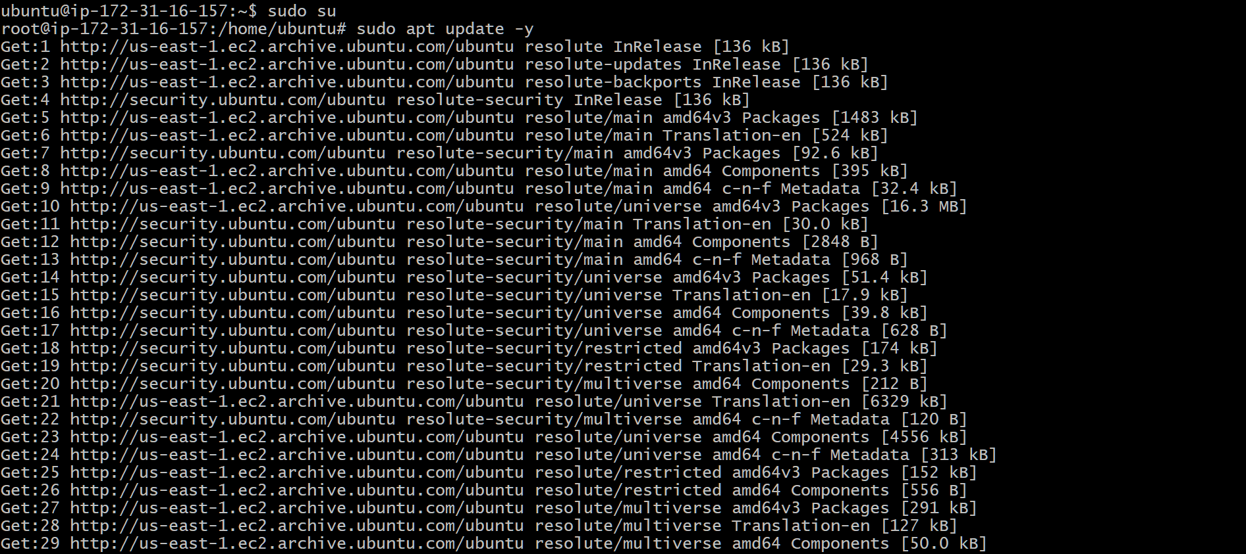

- Install docker on ec2.
sudo apt install docker.io -y
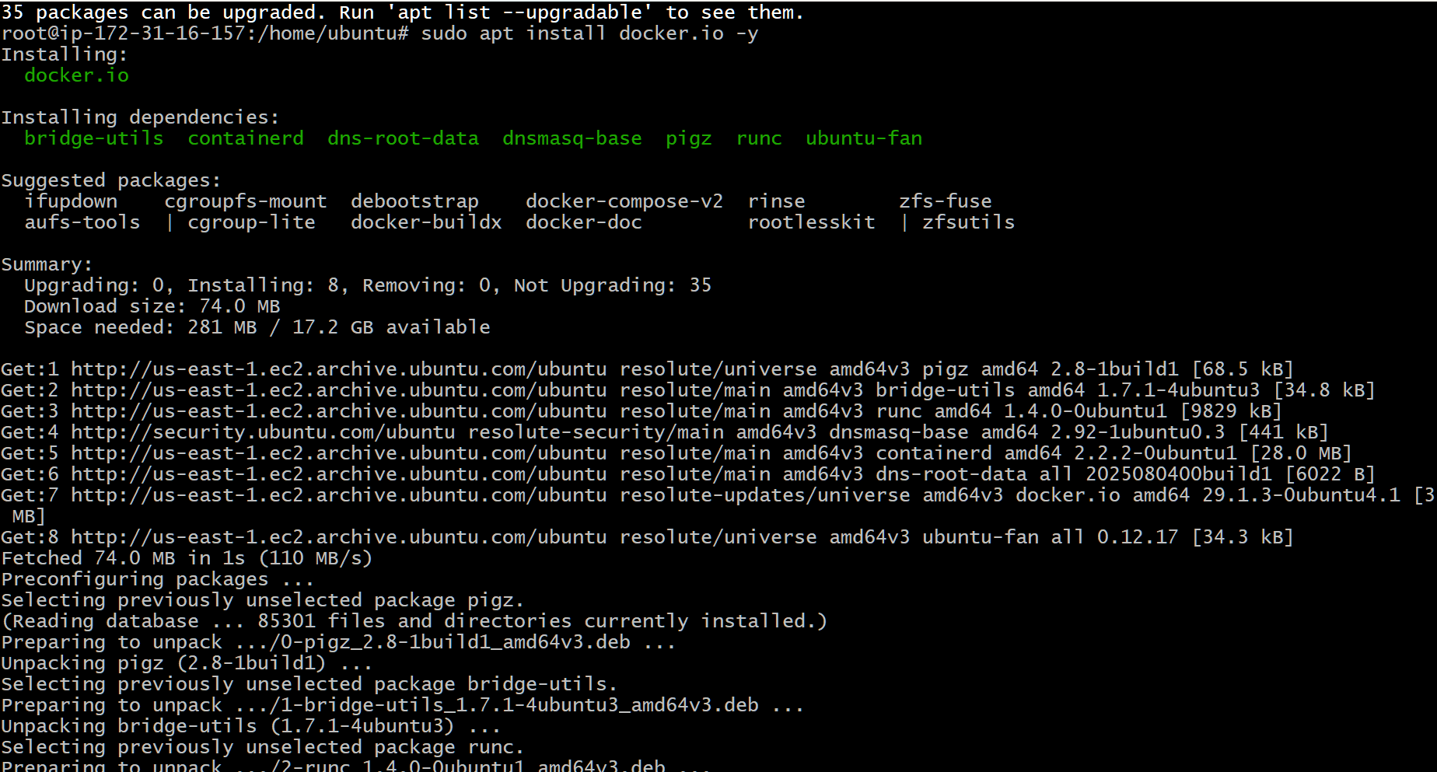
docker --version
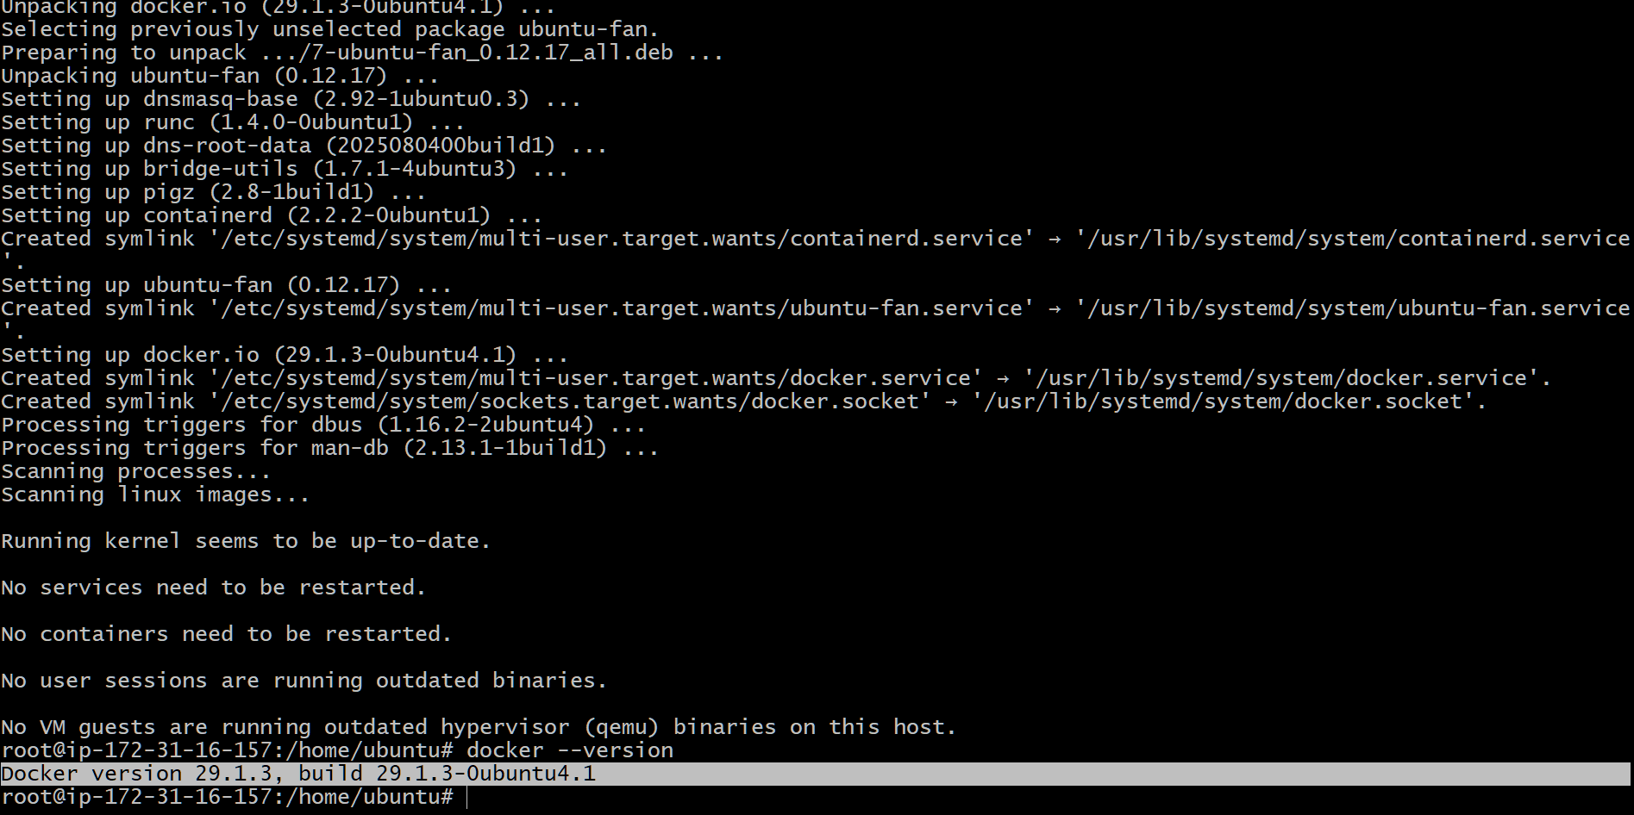

- Pull 5 docker images. (nginx, Apache tomcat, ubuntu, Jenkins, SonarQube)
To pull docker images
For nginx – docker pull nginx
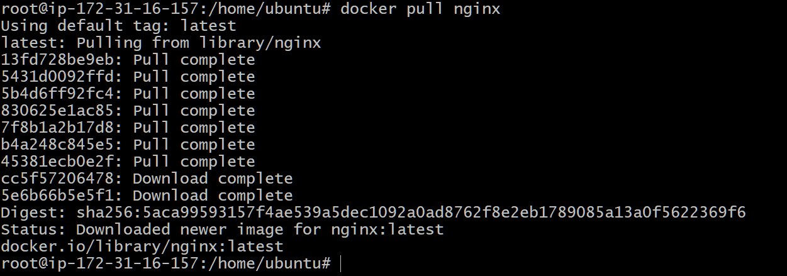
For tomcat- docker pull tomcat
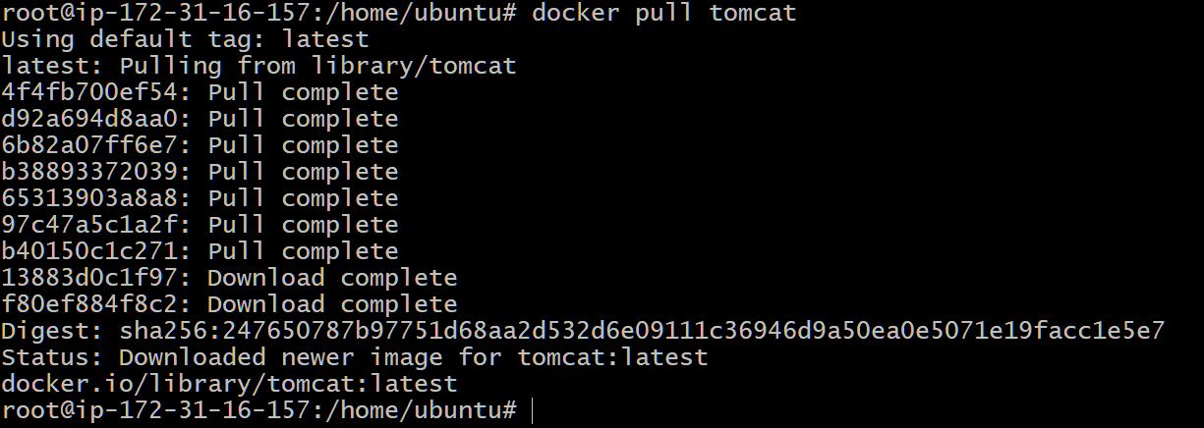
Ubuntu : docker pull ubuntu
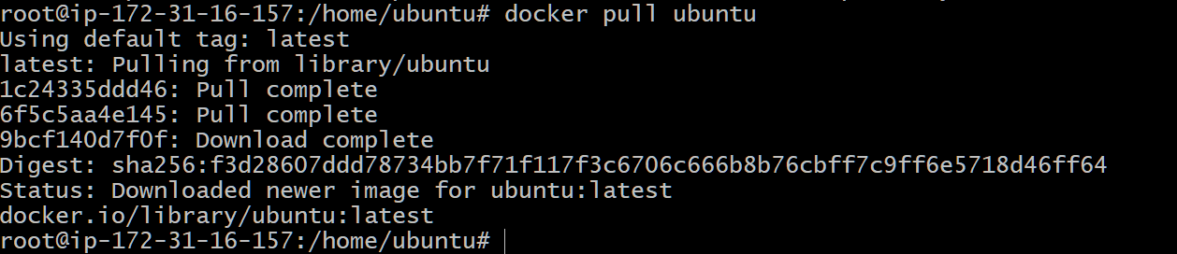

Jenkins : docker pull jenkins/jenkins:lts
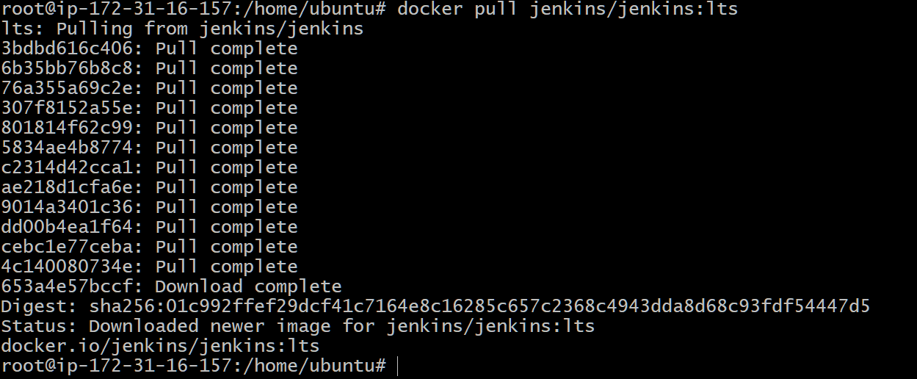
Sonarqube - docker pull sonarqube
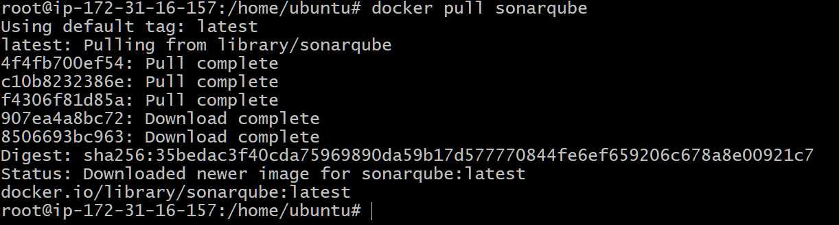
To verify
docker images
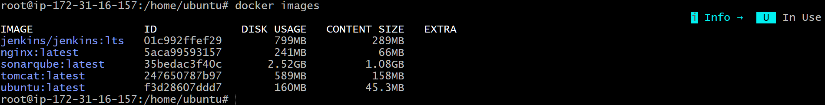

- Run nginx container and expose on port 81.
Run container
docker run -d --name nginx-container -p 81:80 nginx
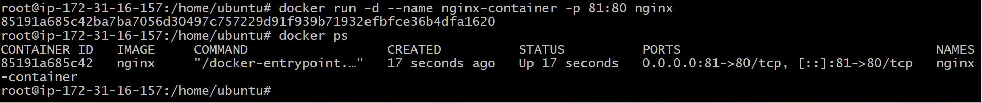
Verified browser and we are able to reach nginx page
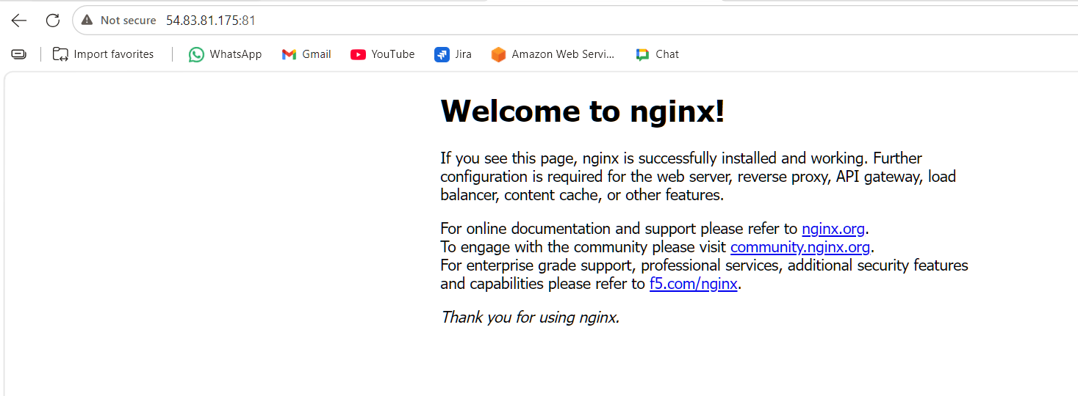
- Delete the Apache tomcat image from local.
First lets check docker images
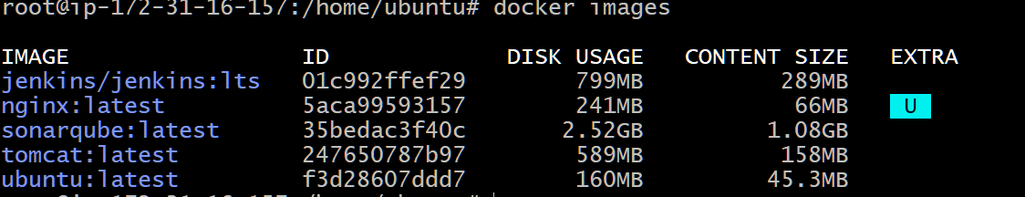
Deleted tomcat image and verified
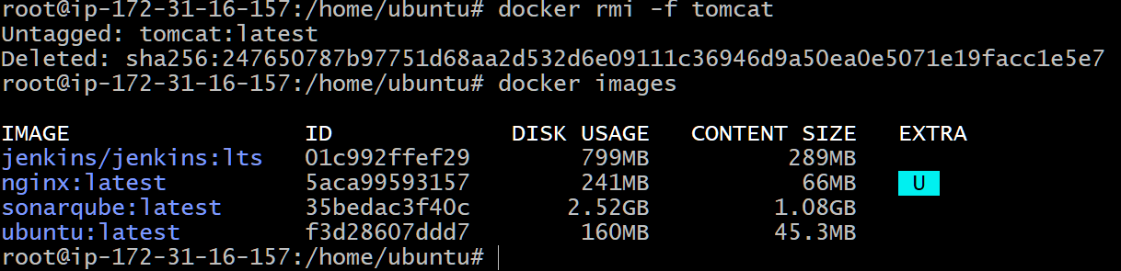

- Inspect the Jenkins image, SonarQube image.
Inspect Jenkins image
docker image inspect jenkins/jenkins:lts
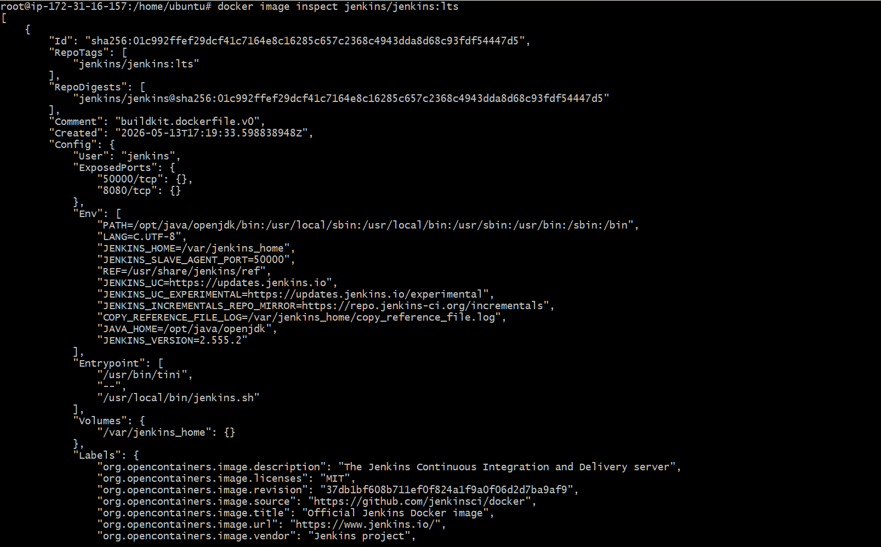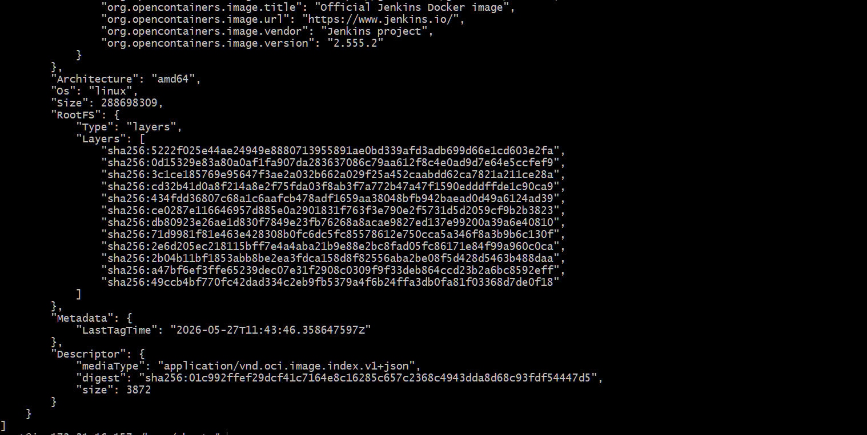
Inspect sonarqube image
docker image inspect sonarqube
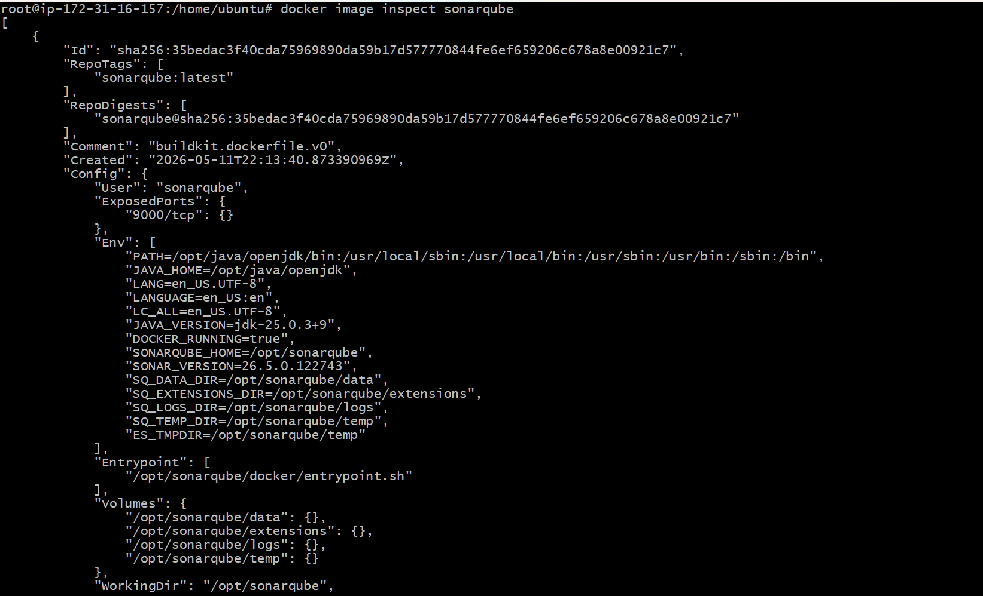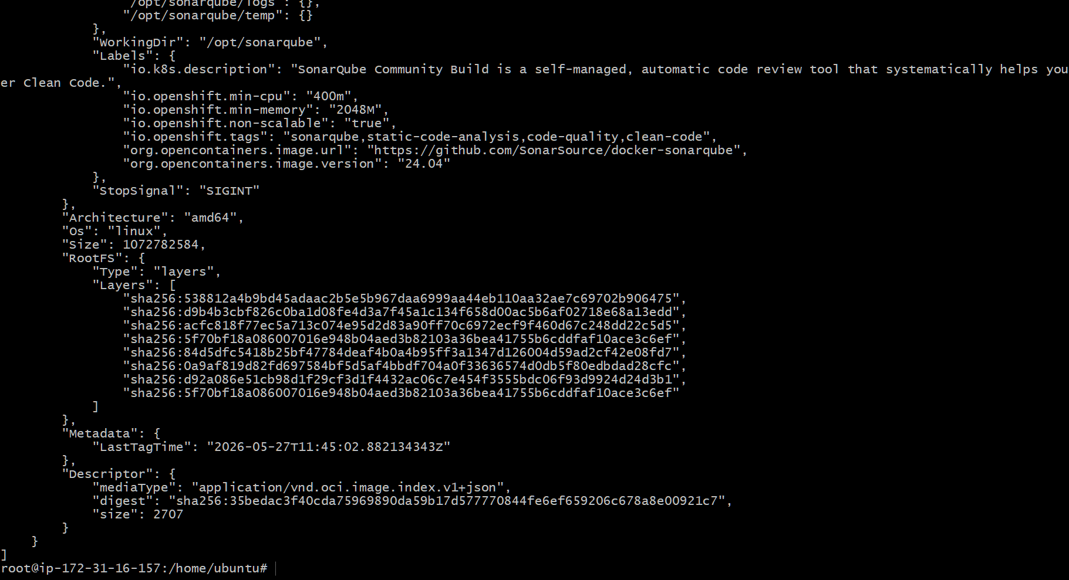

- Run Jenkins container and run one sample job.
Run Jenkins
docker run -d \
--name jenkins-container \
-p 8080:8080 \
-p 50000:50000 \
jenkins/jenkins:lts
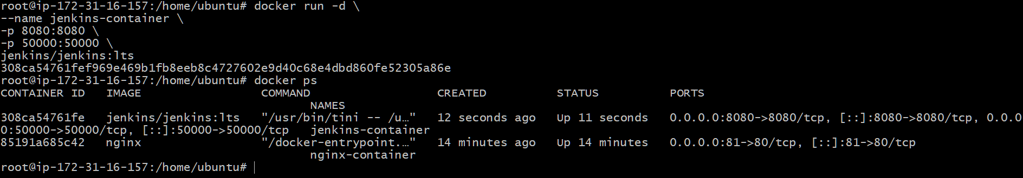
Access Jenkins
To get Jenkins Initial Password
docker exec jenkins-container cat /var/jenkins_home/secrets/initialAdminPassword
Create user and password
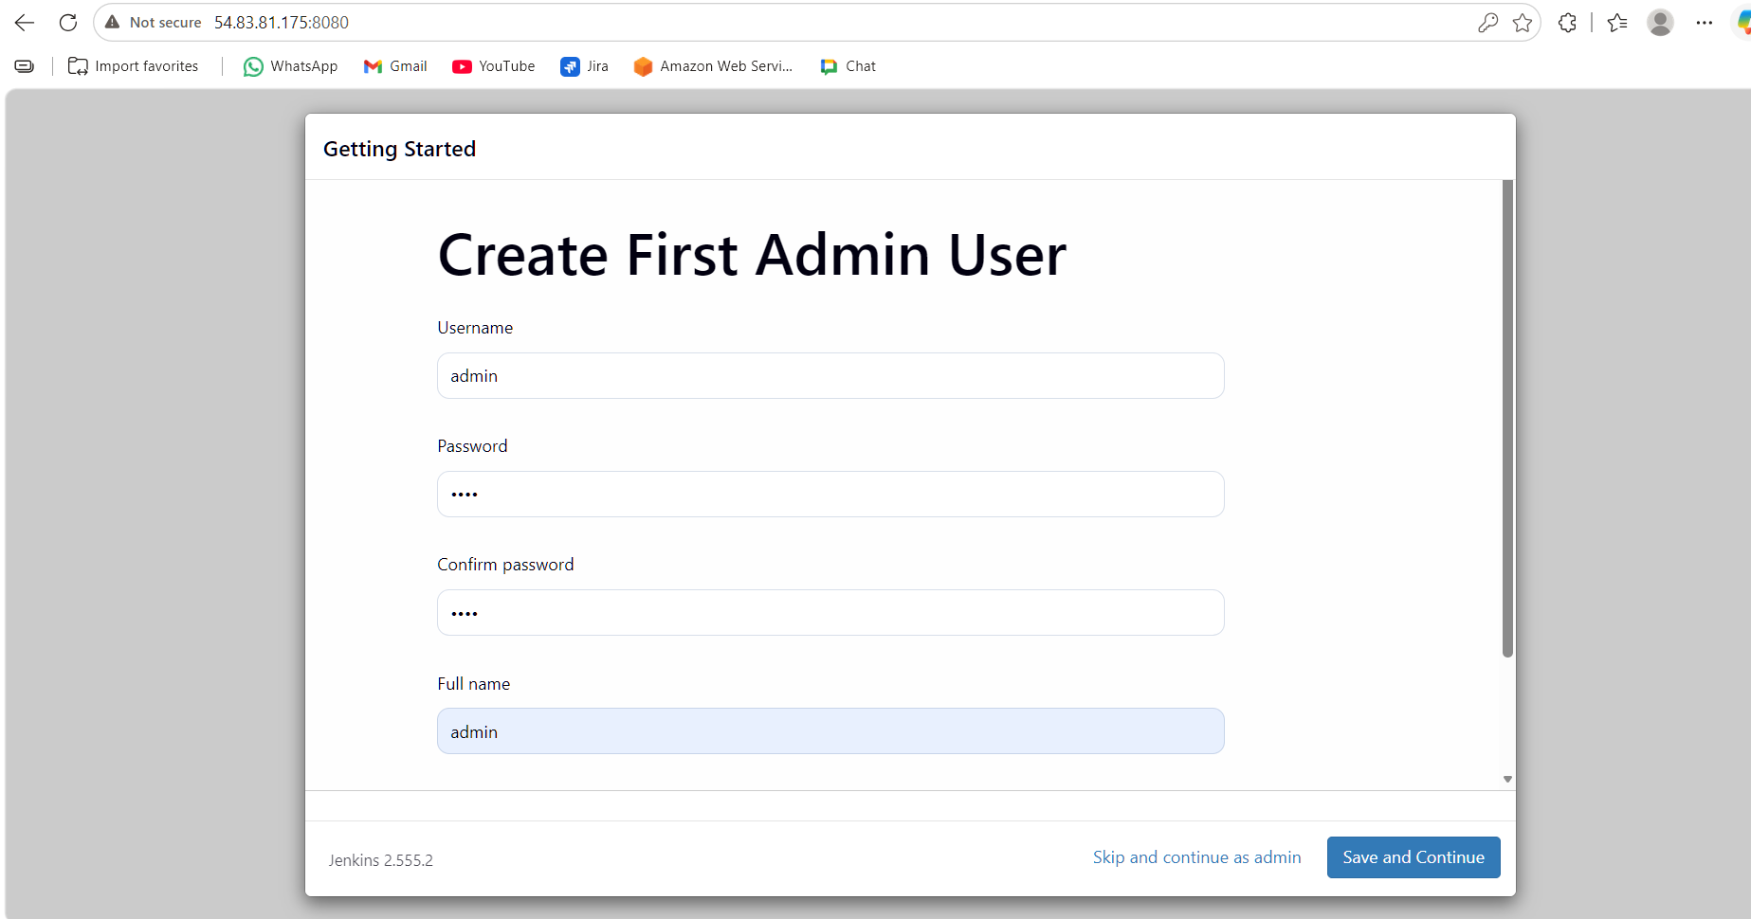

Now lets create a new build
Choose freestyle
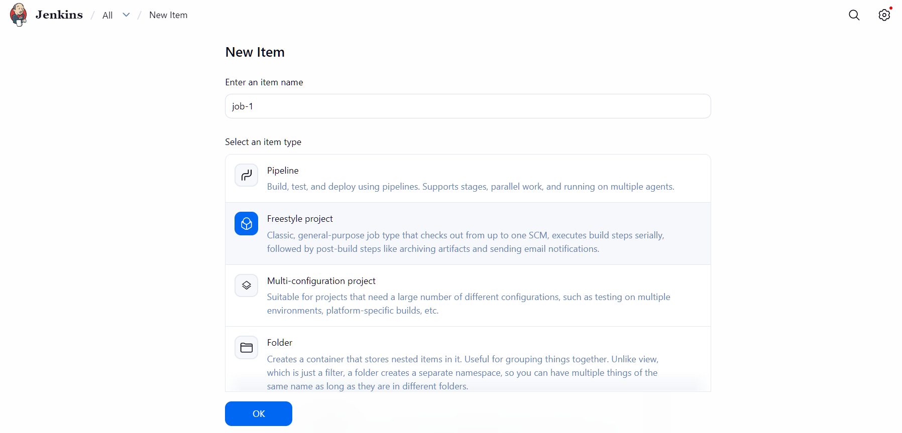
Choose execute shell
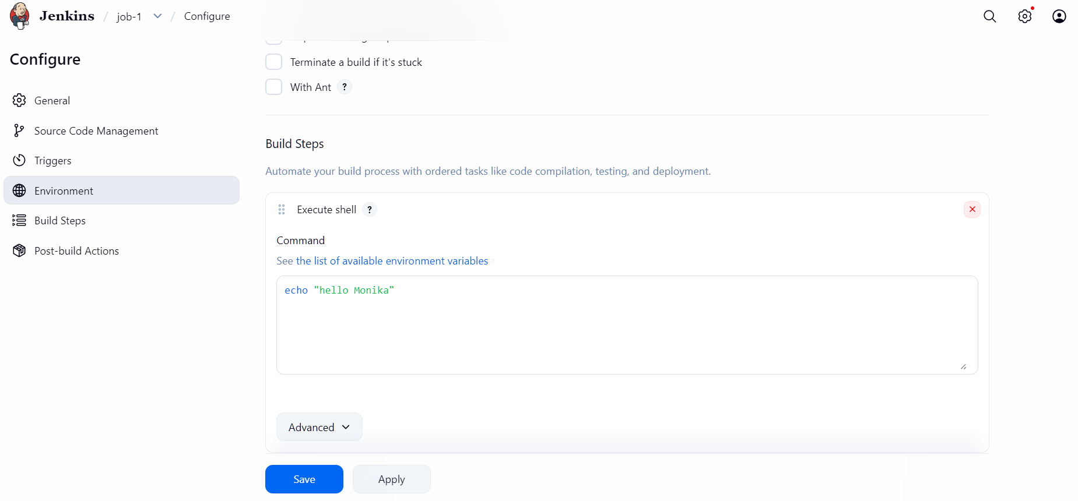
Click on build now to run the job
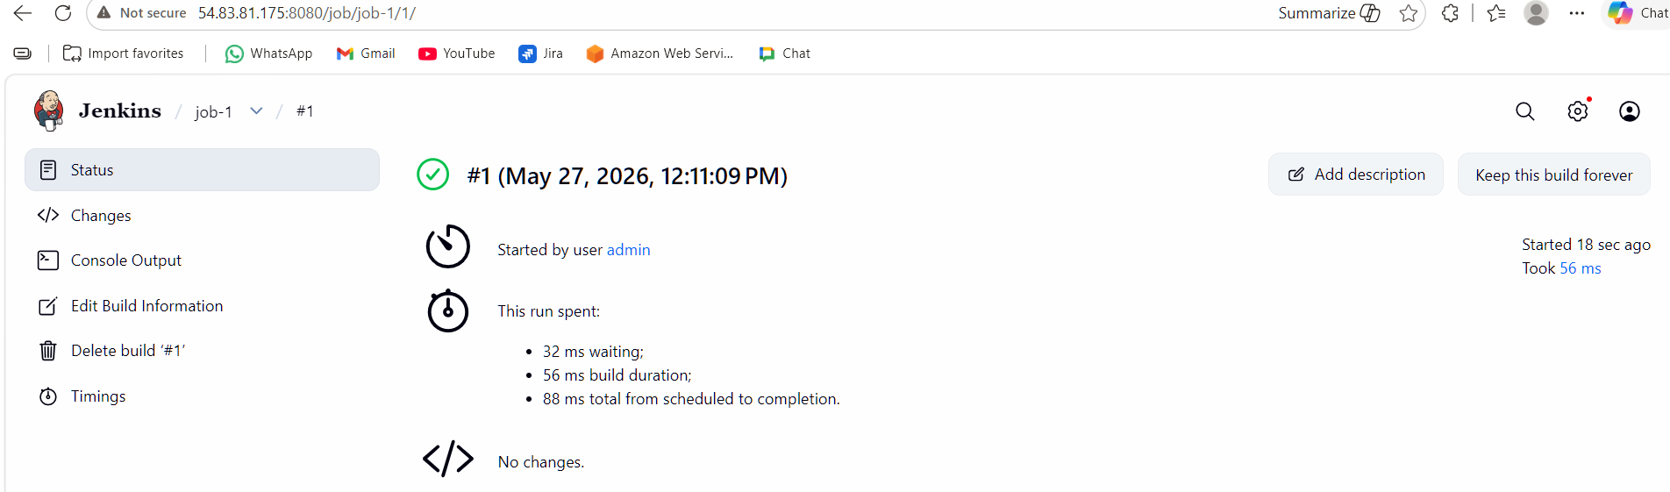
Check the console output
